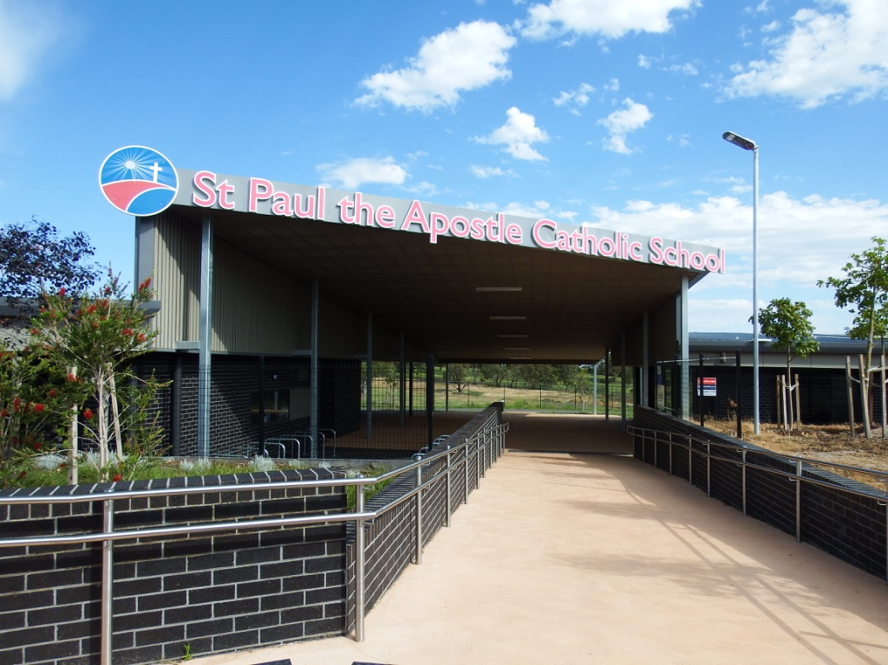

**SPA News**

**No 7: 12 April 2020**

**“Be the Hands, Heart and Voice of Jesus”**

**School Theme 2020**

**Our Commitment to Child Safety:**

“At St Paul the Apostle Catholic Primary School we hold the care, safety and wellbeing of children and young people as a central and fundamental responsibility of our school. Our commitment is drawn from and inherent in the teaching and mission of Jesus Christ, with love, justice and the sanctity of each human person at the heart of the gospel.”

Dear Parents and families,

**Happy Easter**

*I hope you are well and enjoying a well deserved Easter break together with your loved ones in the safety of your homes.*

*As we celebrate Easter and reflect on the miracle of the resurrection of Jesus within the context of COVID19, we can perhaps identify and empathise more readily with the apostles and the followers of Jesus who 2000 years ago, were filled with fear and uncertainty as they locked themselves away from harm and tried to make sense of the events that had just unfolded before them with the unexpected and inexplicable crucifixion of Jesus.*

*But as the minutes and hours grew into days and weeks, the apostles gained new and meaningful insights about themselves and the source of comfort and support they found within their own communities who were also seeking to understand. Slowly at first, they began to experience a renewed hope in the risen Jesus and at Pentecost and emerged from their seclusion with a new found courage, and a determination to make a real difference to the lives of others by spreading the Good News of unconditional God’s Love to all they encountered.*

*It makes me wonder as to how our changed world will look after COVID19 and how we will respond in reshaping our own lives, our families and communities in the months and years ahead.*

**Latest COVID19 Update** As a result of the Coronavirus pandemic, schools have now implemented an online facility to allow children to keep in touch with their learning. Here at SPA, we have adapted our current student portal to provide a link to the Home Learning website that allows home learning to occur. Our staff has been busily preparing for the provision of remote online learning and have dedicated a great deal of time during the school holidays to ensure that your children will have access to engaging and purposeful learning activities.

**To support families, a recommendation from our recent School Leadership Team meeting was to provide access to our Online Home Learning Portal from tomorrow** to enable your family to explore the variety of rich learning opportunities available and to talk about remote home learning with your children.

As a contemporary school, well known for our Cultures of Thinking approaches, we remain firmly committed to designing learning that will engage the children, stimulate their curiosity and love of learning and provide them with opportunities to develop resilience and to experience success. Therefore, we will refrain from providing an over abundance of repetitive worksheets for the children to complete as our young learners are not familiar with this style of learning.

**Remote Home Schooling arrangements from the start of Term Two** As you would be aware, the Victorian State Government has announced that all Victorian Schools will be implementing a **Remote Schooling** program effective **Wednesday 15 April** when Term Two officially commences for our children. This means that from the start of Term Two, the vast majority of our children will be learning from home.

This decision was made to increase physical distancing across the population and prevent the transmission of coronavirus (COVID-19).  **It’s timely to reiterate that it is expected that all students who can learn from home must learn from home**.

In adhering to directives from the Victorian State Government and the CECV (Catholic Education Commission of Victoria) **all students at St Paul the Apostle school will commence Remote Schooling on 15 April 2020 from home and will continue for at least the next four weeks**

**Except for:**

* **children of parents who cannot work from home;**
* **children who are not able to be supervised at home and no other arrangements can be made;**
* **vulnerable children.**

**Remote Schooling** **learning activities** have been designed by their teachers to support the children in their learning from home. Additional learning materials will be provided throughout the school term.

I wish to reassure you that the safety and wellbeing of our school community will remain our highest priority with physical distancing provisions being made for the safety of children and staff.

NB: If you choose to send your child to school, your child will be supervised whilst undertaking the Remote Schooling program within the physical classroom spaces. As such, your child will be undertaking the same program as those children learning at home.

**Maximum ratio of 1 staff :10 children** per learning area around the school buildings. NB:

**The children attending will not necessarily in their class groups or with their normal teacher** (as we will provide a skeleton staff for supervision purposes).

**Social distancing** **will also be enforced** for children in the playgrounds and for parents when dropping children off (at the front gate) and collecting their children (from the front gate).

**Hand Sanitisers and Stationery for Children Attending School** Due to our limited supplies and overdue deliveries here at SPA, parents are requested to provide their children with their own personal hand sanitiser (if available) and to bring their own stationery (pencils and textas) to keep them safe while at school. We will continue to adhere to strict COVID19 hygiene practices here at school.

**Sick Children and Staff whilst at school** Of course, as a vital health and safety issue and following normal school protocols, children who are ill or recovering from illness should not be sent to school. It’s important for families to check their child’s temperature each morning and the staff will also monitor their health with a **temperature check** when entering the school site.

Adhering to directives from the Victorian State Government and the CECV, children (and staff) who are **ill at school will be isolated and sent home immediately**.

**On-Site School - Parent Intentions Form.** If you have a valid reason to send your children to school, please register your intention to send your child/children to school on the accompanying **St Paul the Apostle School, Doreen On-Site School - Parent Intentions Form.** This will enable us to ensure that we have sufficient staff on duty to supervise children in attendance.

I appreciate that this is a very challenging time for all in our community and your cooperation with our Remote Schooling program is very much appreciated. We understand that there will be parents who will need to send their child to school, especially our parents working on the frontline in providing the essential services for the sake of our local and wider communities. We wish you to know that in those circumstances, we are here to support you and your child.

**SPA Home Learning Portal**

Our approach to Home Learning is a multi-faceted approach and focuses on the provision of engaged, enjoyable and purposeful learning activities but will not include reams of uninspiring worksheets. We would like our children to focus on everyday activities that involve reading, writing and mathematics and also to allow our children to extend their learning and thinking through research and activities based on their current Inquiry topic or their own home environment.

Even though our Home learning is hosted online, many of the activities will not be dependent on digital devices or access to the internet. Children can use the digital devices when available, at home however in most cases you will only access the Home Learning website for instructions. A printed copy of the Home Learning Tasks can also be requested if you do have internet access.

Our Student Online Portal now has a link to Home Learning for each Year Level and for each our Specialist areas and Health & Wellbeing, RE, Cooking and Parent Info. Our teachers have posted activities to this web-space that will complement our current learning and teaching foci and allow our children to work independently and at their own pace on interest based tasks.

Teachers will post instructions and set up activities to allow the students to work independently and confidently. In the Prep and Junior Levels, we ask that parents facilitate home learning by reading instructions and explaining activities however Middle and Senior Levels are encouraged to work independently. This is a great opportunity for you to engage in your child/children's learning and spend quality time with each other during these unprecedented circumstances.

School staff will be available throughout the Remote Schooling program and you are asked to make contact directly with your child’s teacher via email (listed on our school’s Home Learning portal) if there are any concerns about your child’s wellbeing or learning program.

NB: Teachers and staff will be available to respond during normal school hours**:** 8.40am – 11.00am, 11.30am – 1.30pm and 2.30pm – 3.45pm

**Our Home Learning web link instructions and expectations will be available tomorrow Monday 13 April 2020 via Flexibuzz or at www.spadoreen.catholic.edu.au.**

**For Further Information during School Hours, please contact: School Office** (92162000) office@spadoreen.catholic.edu.au

**Helen Timmons** (Learning/Teaching & Literacy Leader) [htimmons@spadoreen.catholic.edu.au](mailto:htimmons@spadoreen.catholic.edu.au)

**Ivana Desilva** (Numeracy Leader) [idesilva@spadoreen.catholic.edu.au](mailto:idesilva@spadoreen.catholic.edu.au)

**Nadia Montemurro** (Languages Leader) [nmontemurro@spadoreen.catholic.edu.au](mailto:nmontemurro@spadoreen.catholic.edu.au)

**Jenny McCormack** (School Counsellor) [jmccormack@spadoreen.catholic.edu.au](mailto:jmccormack@spadoreen.catholic.edu.au)

**Geraldine Crowe** (Wellbeing/Learning Diversity Leader) gcrowe@spadoreen.catholic.edu.au

**Adriana Bownds** (Religious Education Leader) abownds@spadoreen.catholic.edu.au

**Frank Fabri** (Deputy Principal/Digital Technologies Leader) ffabri@spadoreen.catholic.edu.au

**Phil Doherty** principal@spadoreen.catholic.edu.au

**Home and Onsite School Learning Programs - CECV The learning program delivered onsite at school should be the same as the learning program delivered to students undertaking remote learning.**  In accordance with Victorian State Government directives, the CECV recommends the following daily guidelines to follow:

**Prep to Year Two – Time Allocation:** Schools should provide learning programs that include the following:

**Literacy** activities that take a total of about 45–60 minutes

**Numeracy** activities of around 30–45 minutes

**Additional learning areas**, play-based learning & physical activity about 30–45 minutes.

**Year Three to Six – Time Allocation:** For students in Years 3 to 6 and Years 7 to 10, schools should provide learning programs allocated as follows:

**Literacy**: 45–60 minutes

**Numeracy**: 30–45 minutes

**Physical activities**: 30 minutes

**Additional curriculum areas**: 90 minutes.

**How Parents Can Support Your Child with their Home Learning**

When you start to think about helping your child to learn from home, remember that no one expects you to be an expert or a school teacher. The most important thing you can do is to continue to provide comfort, support and encouragement to your child as they undertake the learning activities provided.

You can support your child by:

* having a routine and setting expectations
* making sure your child has a space to work in
* providing a level of supervision suitable to your child’s stage of development
* monitoring communications from teachers
* checking in with your child often to help them manage and pace their work
* monitoring how much time your child is spending online.

**Setting Up a Learning Environment at Home**

Every home is different but it’s important to provide a quiet and comfortable space in which to learn. Where possible, extended learning should take place in a space your family shares. For example, a lounge room or dining room. These spaces are preferable over a bedroom, where your child can feel isolated and supervision can be more challenging.

It should be a place:

* that can be quiet at times
* that has a strong internet signal, if possible
* where are in full view and can be easily monitored by you

**Establishing Routines and Expectations for your child**

Start and end each day with a check-in to help your child:

* clarify and understand the instructions they get from their teachers
* help them organise themselves and set priorities for their learning at home.

A healthy daily routine is great for mental and physical health, as well as concentration and learning. Encourage regular exercise breaks. This might mean going for a walk, using exercise DVDs and apps, dancing, floor exercises or using home exercise equipment. Encourage healthy eating habits and make sure they drink enough water.

**Managing Screen Time and Online Safety**

It’s important you keep a balanced approach to home learning. Time spent using digital devices for learning should be broken up with physical exercise and offline learning tasks often. It’s also important that during this time of remote learning we maintain safe and responsible use of information and communication technologies. This includes:

* The appropriate use of digital platforms, privacy and information protection
* When children access devices, please ensure they are set on the strict search filter
* Parents monitoring their use of the devices and limit their time
* Respectful online communication.

**Mental Health and Wellbeing Check-in**

Just as you set aside time for physical exercise, it is important to make time each day to check in on your child’s mental health and wellbeing.

As your child adjusts to their new routine and not being able to see their friends and teachers in person, it is important to be understanding of their feelings of frustration, anxiousness and even anger – every child will react differently.

To support your child, use these mental health and wellbeing check-ins to:

* Provide an opportunity to talk about how they feel and listen to what they say
* Identify one or two things they could do to address what they are concerned or angry about
* Ask how they are going, whether they are finding it easy or hard to learn remotely, and if there is anything they’d like your help with.

There is always a risk that children may be bullied online. If you think this happening to them, support is available on how to talk to your child and your school at: [bully stoppers](https://www.education.vic.gov.au/about/programs/bullystoppers/Pages/default.aspx).

If you have any other concerns about the health and wellbeing of your child, feel free to contact our school directly, to access our staff and resources.

**Advice for Parents of Children with Additional Learning Needs**

* [How you can support your child with additional needs at home](https://www.education.vic.gov.au/parents/additional-needs/Pages/disability-support-home.aspx) – this resource helps you support your child’s learning at home.
* [Understanding learning difficulties for parents: a practical guide](https://uldforparents.com/) – this guide provides you with practical advice about learning difficulties. This includes the evidence base supporting particular intervention programs and a [recommended apps](https://uldforparents.com/further-reading/appendix-5-recommended-apps-list/) list for children with learning difficulties.

We will continue to provide you with **periodic updates** when they become available from the respective Government bodies and the CECV **via our flexi-buzz app and school website**.

This remains a challenging time for your families, our staff and our global community and I thank you for the support and calmness you have demonstrated for the sake of our children.

During this difficult time, we must all take care to support one another. Our thoughts and prayers are with those who may be unwell, and those who are working to keep our community safe.

The message of Easter with the life, death 

and resurrection of Jesus remains one of

hope and a time of renewal.

Warm regards,



Phil Doherty (Principal)